ENGLISH WORKSHOP (phase 5) TyT training

DATE: October 24th /2019

Instructor: Liliana Bedoya.

1. Watch the following images and answer the questions.



1

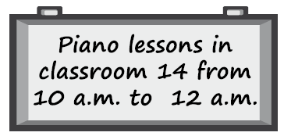23 4

1. What is the context of each advertisement?

* Tu puedes conducer moto aqui.

1. Where could you see each one of the advertisements?
2. Write a sentence saying the opposite information for each image.
3. Write a different sentence giving the same information on each image.
4. Describe the following pictures, take into account appearance, feelings, environment, elements, colors, places, time, other possible aspects according to each one of them.





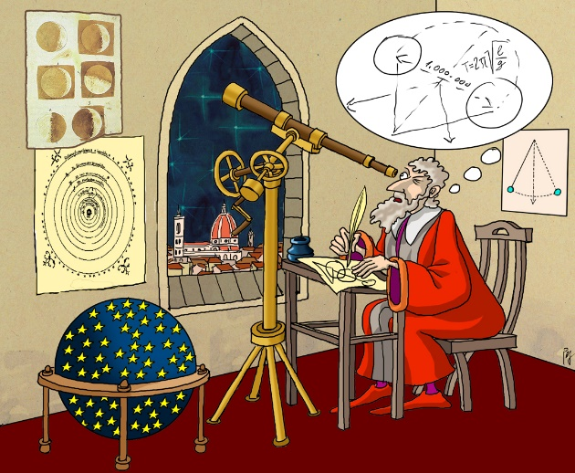

1. Write three short conversations; one at the doctor´s, other with a teacher and the last one with a friend. Then omit some parts and pass the conversation to one of your partners to complete it, give some options, paste in this workshop the answers that your partner wrote.
2. Read the following article and answer the questions.

**Atmosphere of Venus**

Data from the Pioneer spacecraft of NASA apparently prove the theory that the high surface temperature of Venus is due to an atmospheric greenhouse effect caused mainly by a blanket of carbon dioxide. Such a greenhouse effect is created when energy in the form of sunlight easily passes through a planet's atmosphere, warms its surface, and is converted to heat radiation that is then held in by the atmosphere from top to bottom. Venus has a relatively thin atmosphere like the Earth's, but Venus' atmosphere consists of more than ninety percent carbon dioxide, compared to less than four percent in that of the Earth. Because of its higher percentage of carbon dioxide, Venus' atmosphere traps much more heat radiation than does the Earth's. Thus, the Venus studies are believed to be important to the understanding of possible adverse effects on the Earth's agriculture that could result from the long-term use of fossil fuels, which add carbon dioxide to the atmosphere.

**1. According to the passage, data from the Venus study can be used to ----.**  
  
A) measure the amount of carbon dioxide in the atmosphere accurately  
B) increase the emission of carbon dioxide into the atmosphere  
C) test the efficiency of the spacecraft sent to Venus by NASA  
D) predict future agricultural problems on Earth  
E) determine the topography and the surface characteristics of the Earth  
  
**2. We understand from the passage that the atmosphere of Venus ----.**  
  
A) is thinner than the atmosphere of the Earth  
B) contains much more carbon dioxide than that of the Earth  
C) traps less heat radiation compared to the atmosphere of the Earth  
D) blocks out dangerous rays from the sun  
E) is far colder than the atmospheres of other planets in our solar system  
  
**3. One can infer from the passage that ----.**  
  
A) there is no difference between the atmospheres of Venus and the Earth  
B) the atmosphere of the Earth consists of mainly carbon dioxide  
C) the more carbon dioxide in the atmosphere, the warmer the world will tend to get  
D) lack of atmosphere causes a very high surface temperature on Venus  
E) Venus had once enjoyed a climate of the sort hospitable to life.

Taken from: <https://www.grammarbank.com/reading-comprehension-tests.html>